Samuel Ogunfunmi

Purpose:

Date: 10/11/20

**Problem 1)**

**1. Algorithm (Solution Plan for the Problem):**

1. Create a string variable saying “Hello World!”
2. Print index 0
3. Print index 1
4. Print index -1
5. Print index -2
6. Print index 0
7. Print index 15

**2. Program Source Code (copy and paste from IDE):**

def main():

phrase = "Hello world!"

print("What is the value returned by index position 0?")

print(phrase[0])

print("What is the value returned by index position 1?")

print(phrase[1])

print("What is the value returned by index position -1?")

print(phrase[-1])

print("What is the value returned by index position -2?")

print(phrase[-2])

print("What is the value returned by index position 15?")

print(phrase[15]) #IndexError: String index out of range

main()

**3. Program Output Screenshots/Screen Print(s) and/or Error Messages:**

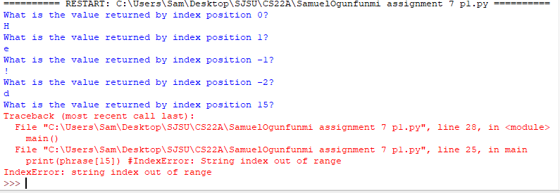

**Problem 2)**

**1. Algorithm (Solution Plan for the Problem):**

1. Create a string variable saying “apple”
2. Print fruit[:]
3. Print fruit[ :3]
4. Print fruit[ 3:]
5. Print fruit[: -1]
6. Print fruit[0 : 11]

**2. Program Source Code (copy and paste from IDE):**

def main():

fruit = "apple"

print("What is the output of fruit[:]")

print(fruit[:])

print("What is the output of fruit[ :3]?")

print(fruit[ :3])

print("What is the output of fruit[ 3:]?")

print(fruit[ 3:])

print("What is the output of fruit[: -1]?")

print(fruit[: -1])

print("What is the output of fruit[0 : 11]?")

print(fruit[0 : 11])

main()

**3. Program Output Screenshots/Screen Print(s) and/or Error Messages:**

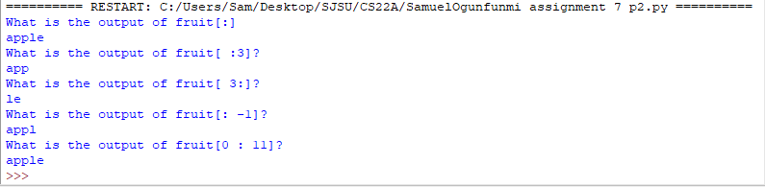

**Problem 3)**

**1. Algorithm (Solution Plan for the Problem):**

1. Create a string variable saying “Hello World!”
2. Print the 6th to second to the last character of the variable
3. Print the 5th character (including the 5th character) of the variable

**2. Program Source Code (copy and paste from IDE):**

def main():

string = "Hello World!"

print(string[5 : -2])

print(string[1 : 5])

main()

**3. Program Output Screenshots/Screen Print(s) and/or Error Messages:**



**Problem 4)**

**1. Algorithm (Solution Plan for the Problem):**

1. Ask user to input a character
2. Create loop that will output a certain amount of rows
3. Create a loop for spacing before and after the row

**2. Program Source Code (copy and paste from IDE):**

def main():

char = str(input("Enter a character for a pyramid:"))

row = 0

while(row < 5): #Continues until row is == 5

row += 1

spaces = 5 - row

counter = 0 #Counts # of times loop runs

while(counter < spaces):

print(" ", end='')

counter += 1

characters = 2 * row-1

while(characters > 0):

print(char, end='')

characters -= 1

print()

main()

**3. Program Output Screenshots/Screen Print(s) and/or Error Messages:**

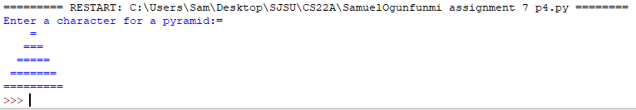

**Problem 5 part 1)**

**1. Algorithm (Solution Plan for the Problem):**

1. Define a count variable
2. Create a while loop that ends after 3 loops
3. Within the while loop create an if statement to determine if the password has been entered correctly
4. Outside of the while loop create an if statement to determine if the requirements for a correct password have not been met after 3 tries

**2. Program Source Code (copy and paste from IDE):**

def main():

count = 0

while count < 3: #While loop that gives users 3 tries

password = input("Enter password: ")

if password == "Password": #Correct password

print("Access granted")

count = 3

else: #Incorrect passwords

print("Access denied.")

count += 1

if count == 3 and password != "Password": #After 3rd try, lock the user out

print("Too many tries. Account Locked")

main()

**3. Program Output Screenshots/Screen Print(s) and/or Error Messages:**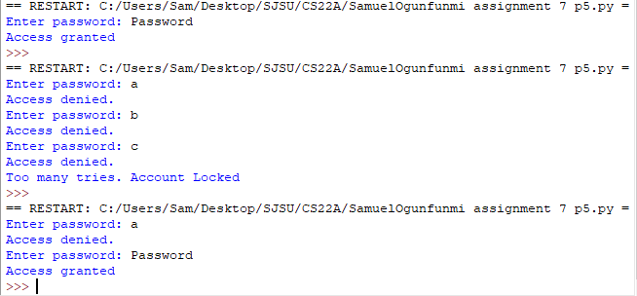

**Problem 5 part 2)**

**1. Algorithm (Solution Plan for the Problem):**

1. Print string in a for loop
2. Remove the spaces from a string
3. Insert commas between characters of a string
4. Create

**2. Program Source Code (copy and paste from IDE):**

def main():

phrase = "Midterm Exam is almost here"

comma = ","

print("1. Traverse/iterate over string using standard for loop:")

for statement in phrase:

print(statement, end=" ")

print("\n")

print("2. Spaces removed from the string:")

print(phrase.replace(" ","")) #Replaces the spaces with no space

print(comma.join(phrase)) #inserts a comma inbetween each character

print("\n")

print("3. Index Position and the Corresponding Character")

phrase2 = "CIS 122 Exam 1 is almost here"

count = 0

while (count < len(phrase2)):

letter = phrase2[count]

print("Index:", count ,"Element:", phrase2[count]) #prints the index # and the character on new lines

#until there are no more characters to print

count +=1

print("\n")

print("4. Iterate over a sub-string/slice using standard for loop:")

for statement in phrase:

print(phrase[ 8:12]) #prints characters 8 through 12 in the string phrase "Exam"

break

main()

**3. Program Output Screenshots/Screen Print(s) and/or Error Messages:**

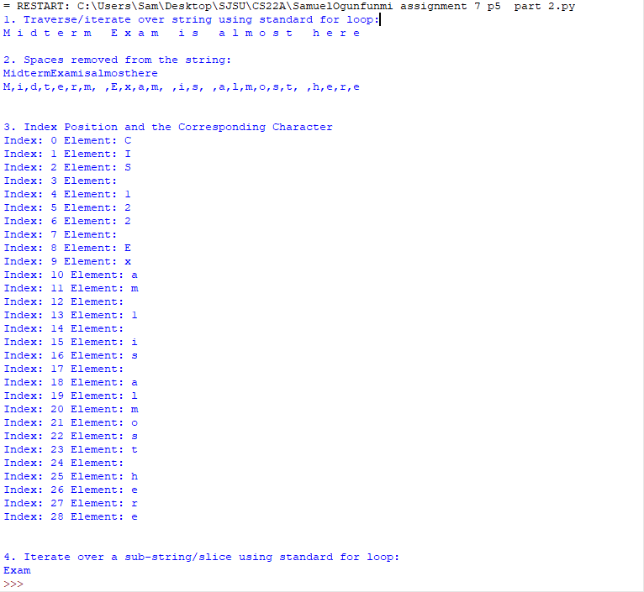

**Conclusion/What you learned writing this program and what problems you encountered.**

I learned how to use string multiplication, write a program using selection and repetition, and iterate over the string using as for-each loop.